Final Report for Syslab
ClearClause: Privacy Policy Seeker and Summarizer
Kevin Okoeguale
5/27/2025
Yilmaz - Period 1

Table of Contents
Abstract……………………………………………………………………………………………3
Introduction ………………………………………………………………………..……………. 4
Background ……………………………………………………………..…………..…… 5
Applications ………………………………………………………..……………….…… 5
Methods ……………………………………………………..…………………………….…….. 7
Results ……………………………………………………….…………………………..………11
Limitations ……………………………………………………….………………...……11
Conclusion …………………………………………………………………...……………. …...12
Future Work and Recommendations ………………………………………...…………. 12
Reference List …………………………………………….……………………………………..13
Appendix A. Source Code Repositories and Materials ………………………………………... 15

Abstract
ClearClause is a Chrome extension designed to address the readability and accessibility challenges presented by online privacy policies. With data showing that a large percentage of internet users either do not read or cannot understand these documents, ClearClause offers a solution: automated, concise, and reliable summaries of privacy policies using modern natural language processing techniques. The system identifies relevant documents on web pages, extracts their content, and generates user-friendly summaries using the BART model. This project aims to reduce privacy fatigue, inform users, and improve online transparency by making critical information more accessible.
Keywords: Natural language processing, privacy policy, summarization

Introduction
In recent years, the average internet user has been confronted with a growing number of privacy policies. These documents are often long, opaque, and written in legal jargon that alienates readers. According to a 2019 Pew Research Center survey, while 81% of people encounter privacy policies regularly, only 13% often read them, and a mere 9% always do. Among those who attempt to read them, a large portion still report not understanding the content fully. A study found that on average, someone would need a college freshman reading level to understand an average privacy policy, yet 43 million U. S. adults possess low literacy skills (Fabian et al., 2017; “Adult literacy”, 2019 ). This disconnect is troubling in a world where data is increasingly commodified.
The idea for ClearClause was born from this gap in user experience. During early brainstorming sessions in Syslab, it became clear that a practical tool to summarize privacy policies would help bridge this information divide. The novelty of ClearClause lies in its seamless integration into the browser and use of advanced transformer-based summarization models to distill privacy policies into readable summaries.
This project is interesting because it applies AI in a way that has the immediate real-world benefit of making the web more transparent and accessible for everyday users.

Background
There are existing efforts to simplify privacy policy understanding, but many fall short in terms of scalability, maintainability, or usability.
Governmental regulation is one possible solution, with public demand high for standardized, nutrition-label-style disclosures. However, with political and legal complexity slowing federal legislation, technological solutions have stepped in to fill the void.
Projects like PrivaSeer aim to make policies searchable but do not provide summaries (Srinath et al., 2021). ToS;DR offers community-annotated summaries and ratings, but relies on volunteer contributions, which limits its scope and update frequency.
Some academic projects such as Joshi and Finin’s summarizer (Joshi & Finin, 2017) have shown promise in extracting key clauses, but haven’t evolved into user-facing tools.
This landscape inspired ClearClause: a hybrid of research-backed summarization and real-time browser integration.
Applications
The primary application for ClearClause is for everyday internet browsing. It benefits general consumers who want quick, understandable summaries before accepting terms; parents and Educators who are Teaching students about digital literacy and informed consent; regulators who may use it as a diagnostic tool for identifying obscure or misleading privacy terms; and, researchers who could use it to analyze trends in privacy policy content over time.
The tool is particularly useful on major platforms with lengthy, difficult-to-navigate privacy documents. It functions as a browser companion, reducing cognitive load and promoting informed digital behavior.

Methods

Systems Architecture Overview
As illustrated in the flow diagram in Figure 1 and the code made available in Appendix 1, before the extension is initiated, the user visits a website, preferably the webpage of the privacy policy. After the user clicks on the extension icon, the popup script scans for privacy policy indicators (URL keywords, title, meta tags). The text from the identified policy page is extracted via DOM parsing. The cleaned text is then sent via POST to a serverless BART instance on RunPod. Finally, the summary is returned and displayed on the page.

Figure 1
Extension Method Diagram
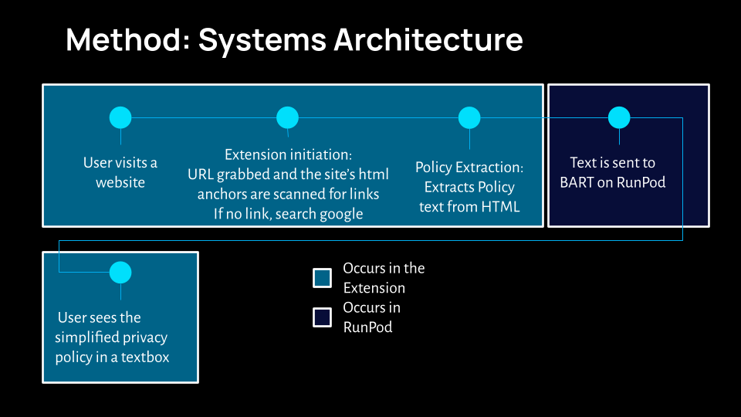

The NLP model being used is Facebook AI’s BART (Lewis et al., 2019; Figure 2). It is an encoder-decoder transformer with 12 layers in the encoder and 12 layers in the decoder. Overall, it has 140 million parameters. It was trained by Facebook's AI using denoising autoencoding which is masking out parts of text and predicting the original. The reason for this choice was that BART balanced grammatical fluency and information retention better than models like T5 in this domain during the early testing phase of this project.

Figure 2
Facebook’s Bart Model

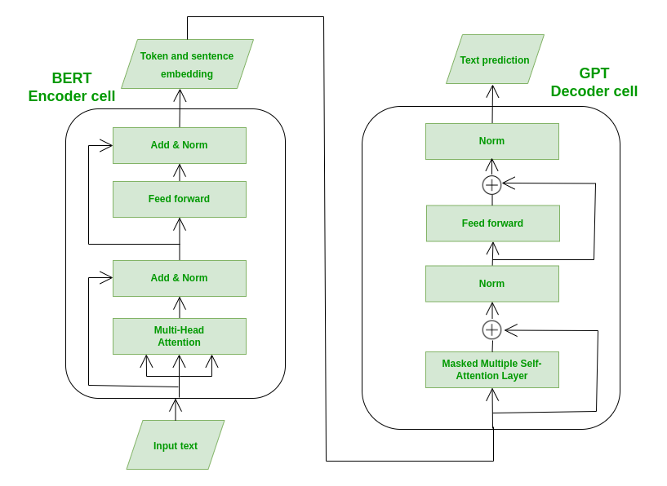
Note. Adapted from “Website Summarizer using BART”, by GeeksforGeeks (2025)

Tools Used
The front end of the application uses the Chrome Extensions API while the backend is a “Serverless” instance on RunPod where the model is hosted using RunPod Serverless Cloud. The major library that was used was HuggingFace Transformers.
Experiments and Learnings
Initial trials with Google’s T5 model showed less coherent summarization. Also, attempted using client-side inference but was limited by size and compute constraints. As an extension, caching common policy summaries could improve latency—explored but not implemented due to time.

Results
Summaries are usually generated in 60–90 seconds for policies around 2000 words (e.g., U.S. Dept. of State), and the length of the text is reduced by approximately 60%. The generated summaries are significantly easier to understand, a fact that was verified through informal peer testing. In terms of success rates, text extraction, and summarization worked on ~85% of tested sites. The policies that created challenges for the extension included those like Google’s which load content dynamically or hide it behind JavaScript, limiting the extension’s reach without advanced scraping techniques.
Limitations
The major limitation for reaching a global user base is that only English policies are fully supported due to the model's training data as well as the English keywords used to search for privacy policies. There also happen to be times when the extension fails when titles/URLs are unconventional. As mentioned previously, sometimes the content itself can cause issues: JavaScript-heavy sites with obfuscated content remain a hurdle. Lastly, summarization times are dependent on serverless resource availability on RunPod, which can create delays.

Conclusion
ClearClause represents a step toward more accessible digital consent. Summarizing privacy policies in plain language and integrating the process into the user’s browser experience helps users make more informed decisions. While not perfect, the current application demonstrates that large language models can be applied practically to solve real-world transparency issues on the internet.
Future Work
There are a multitude of additional features that would benefit this project including adding multilingual support which would entail finetuning BART or using a multilingual model like mBART. Another is caching summaries which, in this context, means storing summaries for frequently visited domains to reduce summarization times. Adding clause-level classification (e.g., "data retention", "third-party sharing") could further improve the reading experience by allowing a user to find exactly what they are looking for with a search. As mobile devices are becoming more common to use for browsing the internet, creating a mobile version of the extension would allow for a significantly greater number of consumers to be assisted in reading privacy policies especially when combined with the aforementioned features. Adding some method of receiving user feedback would be beneficial as well as the extension continues to be updated. The most necessary improvement for the extension would be enhancing its legal alignment by consulting with privacy professionals to enhance summary fidelity and to better highlight legal red flags.

References

About tos;dr. About Us - ToS;DR. (n.d.). https://tosdr.org/en/about
Fabian, B., Ermakova, T., & Lentz, T. (2017). Large-scale readability analysis of privacy policies. Proceedings of the International Conference on Web Intelligence, 18–25. https://doi.org/10.1145/3106426.3106427
GeeksforGeeks. (2025, April 28). Website summarizer using Bart. GeeksforGeeks. https://www.geeksforgeeks.org/website-summarizer-using-bart/
Google. (n.d.). Chrome extensions : chrome for developers. Chrome for Developers. https://developer.chrome.com/docs/extensions/
Joshi, K. P., & Finin, T. (2025, March 4). Teaching machines to understand – and summarize – text. The Conversation. https://theconversation.com/teaching-machines-to-understand-and-summarize-text-78236
Lewis, M., Liu, Y., Goyal, N., Ghazvininejad, M., Mohamed, A., Levy, O., Stoyanov, V., & Zettlemoyer, L. (2020). BART: Denoising Sequence-to-Sequence Pre-training for Natural Language Generation, Translation, and Comprehension. Association for Computational Linguistics (ACL), In Proceedings of the 58th Annual Meeting of the Association for Computational Linguistics, 7871–7880. https://doi.org/10.18653/v1/2020.acl-main.703
National Center for Education Statistics. (2019, July). Adult Literacy in the United States. National Center for Education Statistics. https://nces.ed.gov/pubs2019/2019179/index.asp
Pew Research Center. (2019, November 15). Americans and privacy: Concerned, confused and feeling lack of control over their personal information. Pew Research Center. https://www.pewresearch.org/internet/2019/11/15/americans-and-privacy-concerned-confused-and-feeling-lack-of-control-over-their-personal-information/
Thomas Wolf, Lysandre Debut, Victor Sanh, Julien Chaumond, Clement Delangue, Anthony Moi, Pierric Cistac, Tim Rault, Remi Louf, Morgan Funtowicz, Joe Davison, Sam Shleifer, Patrick von Platen, Clara Ma, Yacine Jernite, Julien Plu, Canwen Xu, Teven Le Scao, Sylvain Gugger, Mariama Drame, Quentin Lhoest, and Alexander Rush. 2020. Transformers: State-of-the-Art Natural Language Processing. In Proceedings of the 2020 Conference on Empirical Methods in Natural Language Processing: System Demonstrations, pages 38–45, Online. Association for Computational Linguistics.

Appendix A
Source Code Repositories and Materials
The materials that were used in conducting this research are available through the following links:
- Google Drive folder containing the complete source code and other materials for the project: [ Research (Kevin Okoeguale, pd 1)](https://drive.google.com/drive/folders/1RNrg165m4-0PYd25vDoL5EHBgN-AVW8M?usp=sharing)
- Github repository containing the complete source code and other materials for the project: [https://github.com/kevo-ops/ClearClause/tree/main](https://github.com/kevo-ops/ClearClause/tree/main)
- Zipped Google Drive folder containing the items present in the Github repository: [Zipped Github (ClearClause-main).zip](https://github.com/kevo-ops/ClearClause)

